

ICT
Name:
Class:


Primary Six
Information and Communication Technology
1st Term

Name:………………………………………
Class:…………………………………………
Primary 6
First Term
ICT Binder
2026-2027

Theme 1

Lesson 1
Computer Network Devices

Networks: are groups of devices or things that are connected to each other for a common purpose.
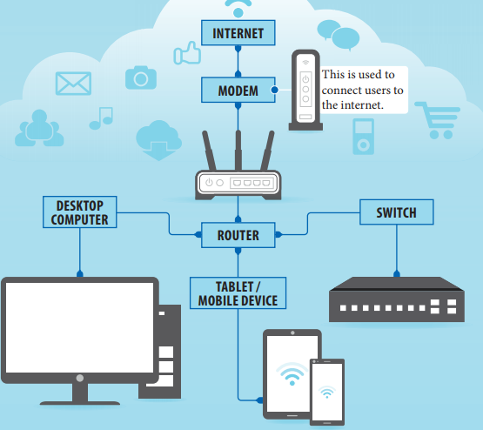
Making connections:
- Wired networks use physical wiring and
cables, which are plugged into ports on
devices.
- Wireless networks connect without wiring
(wireless or Wi-Fi).

Connection devices

It’s a device that connects a local area network (LAN) to the internet.
It converts the signal from the internet service provider (ISP) which transforms into a digital signal that can be read by devices.

Artificial Intelligence (AI)
- AI is a term for computer applications that perform complex tasks that simulate the thinking and performance of the human element.
- It works to imitate sounds when provided with the tone of voice of an actual human being.

Questions
Q1: Put ( ) or ( ):
- Computer networks connect computers with each other. ( )
- Wireless networks use physical wiring and cables. ( )
- Devices can be connected without wiring (Wireless or Wi-Fi). ( )
- A switch is a device that connects a local area network to the internet. ( )
- Switches help to make connections easier and faster. ( )
Q2: Choose the correct answer:
- …………… are groups of devices that are connected to each other.
a. Keyboards b. Networks c. Computers
- A …………. converts the signals from the internet service provider (ISP) into digital signals.
a. modem b. port c. router
- …………….. performs complex tasks that simulate the thinking of the human element.
a. AI b. IoT c. ICT
- AI stands for………………..
- a. artificial information b. electronic intelligence c. artificial intelligence
- ………………... networks connect devices with wires and cables.
a. Wired b. Wireless c. Wi-Fi

Lesson 2
Future technology

Augmented reality, virtual reality, and artificial intelligence may seem futuristic, but they are already being used in everyday life.
Virtual Reality (VR)
It is a virtual 3-D environment that allows users to explore and interact with the surroundings, as if it were reality.
- To experience VR:
- Users often wear a VR headset that blocks out the real world and provides views that immerse the user into another world.
- In the classroom, VR can take you to a world where insects are bigger than you, so that you can study them closely.
- It can take you to a museum thousands of miles away, or to a historical site hundreds of years ago.

Augmented Reality (AR)
- It combines the real world with a virtual world by adding images using computers.
- Augmented reality can be done through:
- Smartphone camera.
2. Tablet.

- This will show a 3-D model of what the real world looks like:
- Students in math class can point their smartphone camera at a flat surface and project a 3-D image, as if the figure is in front of them.
- AR helps students become active participants in learning and makes learning more memorable.
Artificial Intelligence (AI)
- It’s the ability of the computer to think, learn, and deduce.
- The computer learns by analyzing the available examples, such as predicting the word you will write based on words you have written previously.
- AI is used to unlock your phone with facial recognition.
Futuristic technology can improve everyday life for:
- People of determination.
- Disabled individuals can use virtual assistants powered by AI to accomplish everyday tasks such as:
- Making phone calls.
- Navigating their computer using their voice or sign language.

Questions
Q1: Put ( ) or ( ):
  - AR, VR, and AI are not used in our lives yet. ( )
  - In the classroom, VR can take you to a world where insects are smaller than you. ( )
  - AR helps students become active participants in learning. ( )
  - AR shows a 2D model of what the real world looks like. ( )
  - AI is the ability of the computer to think, learn, and deduce. ( )
  - People of determination can use virtual assistants to make phone calls. ( )
  - VR stands for Visual Router. ( )

Q2: Choose the correct answer:
- …………. is a virtual 3-D environment that allows users to explore and interact with the surroundings, as if it were reality.
a. VR b. AR c. AI
- …………. combines the real world with a virtual world by adding images using computers.
a. Internet b. ICT c. AR
- Augmented reality can be done through……………….
a. smartphone cameras b. tablets c. (a and b)
- AR shows a …………………of what the real world looks like.
a. 3-D model b. picture c. video
- …………… is used to unlock your phone with facial recognition.
a. EKB b. IoT c. AI

Lesson 3
Assistive technology for people with special needs
Cutting-edge technology
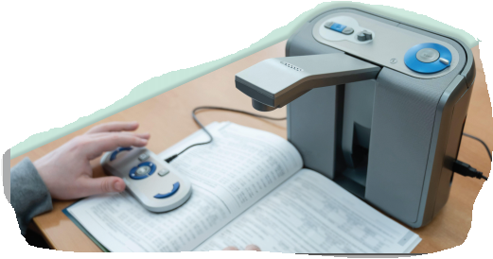
It is the latest and most advanced version of a service or a product.
Examples:
- Artificial intelligence (AI)
- Augmented reality (AR)
- Virtual reality (VR)
Assistive technology for people of determination
- Screen magnification software.
- Hearing aids.
- Programs that turn speech to text and text to speech.
It is important to evaluate these new technologies. By evaluating, society is better informed to make decisions.
There are different evaluation tools that we can use, like:
- Cutting-edge technology has transformed life into ways that were unimaginable even a while ago.
- It helps in education and improves lives and inclusion in society, such as the “smart gloves” that empower deaf people to translate their signs into spoken or text output.

User experience
It refers to how to use the product and interact with it, as well as how to evaluate the experience. It is often broken into different areas, and can be positive or negative, for example:
- Accessible: Is it accessible for people of determination?
- Credible: Are the company and its products trustworthy?
- Desirable: Does the product meet your needs?
- Findable: If there is an issue with the project or service, can I find the solution?
- Usable: Is it easy to use?
- Useful: Is it practical
Meeting Needs
The user’s experience is interlinked with the development of products and services. For example, cutting-edge assistive technology is varied, but the goal is the same (to improve someone’s independence and integration in society).

Questions
Q1: Put ( ) or ( ):
- Cutting-edge technology is the oldest and most advanced version of a service or a product. ( )
- Assistive technology helps people of determination. ( )
- Hearing aids are types of assistive technology for people of determination. ( )
- Through evaluation, the community will be better informed to make decisions. ( )
- Advanced assistive technology has different goals. ( )
Q2: Choose the correct answer:
- ……………….technology is the latest and most advanced version of a service or a product.
a. Cutting-edge b. Smart c. Application
- Examples of cutting-edge technology: ……………….
a. AI b. AR c. VR d. all the previous
- …………….enable deaf people to translate their signals into text or spoken output.
a. Screen magnification software b. Smart gloves c. Hearing aids

Q3: Match:
A | B
- Credible | ( ) Is this technology available for people of determination?
- Usable | ( ) Are the company and its products trustworthy?
- Useful | ( ) Does the product meet your needs?
- Accessible | ( ) If there is a problem with the project or service, can I find a  solution?
- Desirable | ( ) Is it easy to use?
- Valuable | ( ) Is this technology practical?
- Findable | ( ) Does this technology improve my life or help me learn?

Lesson 4
Digital Search Tools

- Useful digital editing tools
Copy, Paste, and Cut are some of the most commonly used word processing commands and are very useful when copying, pasting, and cutting information or images into a word processing file.




- Digital search tools
- Internet searches, specialized search engines, and verified online libraries all search for information, but the results will be different.
- Knowing the results that you need helps in determining the search tools you could use.
- Search engines
- Search engines help people search the internet for websites based on keywords and phrases.
- They are user-friendly, very fast, and often provide several results.
- Use your evaluation skills to ensure the content you select is credible and accurate.
- Databases
- Databases are a collection of information that is typically stored in a computer system and can be accessed, for free, through your school.

  - You can also search for information from magazines and newspapers through the databases on the computer in the school library.

  - EKB is an example of a general database that covers many subjects. The results will be credible and accurate.

- Library catalogs
- It is a database that includes all the items owned by a library.
- A library catalog search may include recently published books, including e-books with the most recent research about a subject, such as the catalog of the Library of Alexandria, which you can use through the library’s website on the internet through the following link: “https://www.bibalex.org”.

- Conducting a database search
- When you search through any database, use a keyword search.
- Review the results for subject headings and redo the search with those terms.
- You can use other database fields, such as an author’s name or a journal title, to narrow down a search. Limiting a search range by specifying dates will help you find the most up-to-date research.

Questions
Q1: Put ( ) or ( ):
- Copy, paste, and cut are some of the most commonly used word processing commands. ( )
- Copy and paste commands are used for images only. ( )
- Knowing the results that you need helps in determining the search tools you could use. ( )
- Internet searches, specialized search engines, and verified online libraries all search for information, and the results will be the same. ( )
- The library catalog is a database that includes all the items owned by a library.( )
- You can’t search for information from magazines or newspapers. ( )
- Search engines are user-friendly, very fast, and often provide several results. ( )
- Limiting a search range by specifying dates helps you find the most up-to-date research. ( )
Q2: Choose the correct answer:
- Search engines help people to search the internet websites based on the ……………. and phrases.
a. comments b. hints c. keywords
- Databases are a collection of …………….
a. information b. photos c. websites
- …………….is an example of a general database that covers many subjects.
a. WWW b. EKB c. ICT
- Use your …………….to ensure the content you select is credible and accurate.
a. evaluation skills b. Facebook account c. e-mail

- …………….is one of the library catalogs.
a. EKB b. Library of Alexandria c. Google
- The URL of The Library of Alexandria is …………….
a. www.h5b.org b. www.ekb.eg c. www.bibalex.org

Lesson 5
How Operating Systems Work
- An operating system (OS) is the software that:
- Manages the computer’s functions, such as memory, drives, printers, and other devices.

- Includes accessible devices such as screen readers and magnifiers.
- Runs computer software and hardware.
- Allows users to communicate with the computer easily.
- Most computers are pre-loaded with an operating system.

- Microsoft Windows is set up on most computers worldwide.
- Mac OS runs on Apple computers.
- Mobile Operating Systems:
The most popular mobile operating systems are Android and Apple iOS. Android uses open-source software, which means a person can change and read the programming code. Apple iOS is closed; it can’t be seen or changed by the public.
- Both Android and iOS perform the same basic functions, such as:
  - messaging
  - web access
  - video chat
  - Touch function

- Cutting-edge operating systems:
Other types of operating systems power different types of cutting-edge technologies.

For example, the Robot Operating System (ROS) is an open-source software used for building robot applications.

Multiple operating systems are powering self-driving cars, including those developed by Apple CarPlay and Windows TM Automotive, as well as individual car companies.
- HTML (Hypertext Markup Language):
HTML is commonly chosen for website creation because:
- It is easy to learn and use.
- Allows creators to add elements such as text, links, images, audio, and videos to their web pages.
- It enables you to make changes easily, and it is compatible with all the major web browsers.

Questions
Q1: Put ( ) or ( ):
- An operating system is a program that controls computer functions. ( )
- Mac OS is on most computers worldwide. ( )
- Closed-source software allows anyone to easily read or change the programming code. ( )
- Both Android and IOS perform the same basic functions. ( )
- There are multiple operating systems powering self-driving cars. ( )
- Programming languages are usually open-source. ( )
- HTML allows creators to add text, links, and images only. ( )
- HTML is easy to learn and use. ( )

Q2: Choose the correct answer:
- Computer functions could be ………………., and other devices.
a. memory b. drives and printers c. all the previous
- ………………runs only on the Apple computers.
a. Windows b. Mac OS c. Android
- …………………. is used on iPhones and iPads.
a. ROS b. Windows c. Apple IOS
- Android uses "…………………." software.
a. open-source b. closed-source c. free source
- ROS is an open-source software used for building …………… applications.
a. robot b. smartphone c. laptop
- Programming languages are instructions to a computer given in .………………….
a. questions b. codes c. pictures
- Programmers use (HTML) to create ……………...
a. presentations b. videos c. web pages

- HTML stands for ……………... Markup Language.
a. Hypertext b. Hyperlink c. Hyperwords

Lesson 6
I Am a Web Designer
- HTML tags
- Hyper Text Markup Language (HTML) is the standard programming language used to create web pages.
- It describes the structure of a web page and consists of a series of elements such as headings, paragraphs, links, and images.
- They are the building blocks of web pages.
- Web browsers read HTML documents and display the content according to the HTML tag.
- Tags have three main parts: an opening tag, the content, and a closing tag.
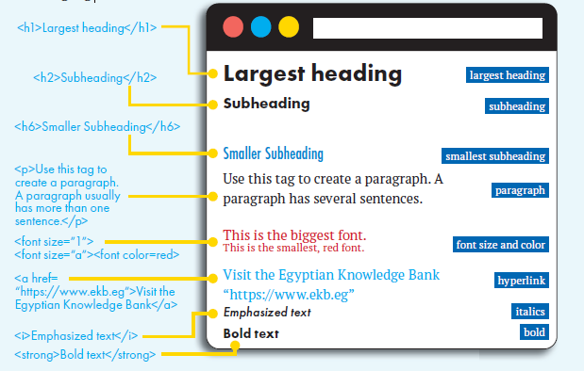

- Website Design
- HTML elements break up web pages to make them easier to scan, read, and navigate.
- An HTML code can also help people with low vision to distinguish between parts of a web page.
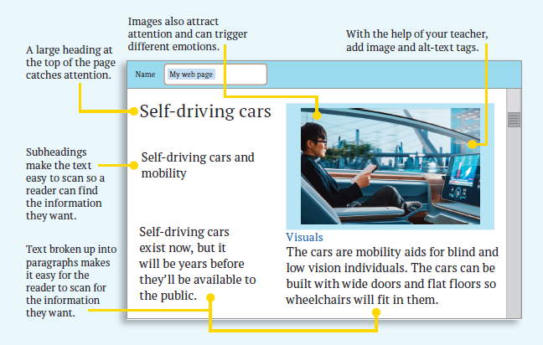

Questions
Q1: Put ( ) or ( ):
- HTML is used to create presentations. ( )
- Web browsers can’t read HTML documents. ( )
- An HTML code helps people with low vision to distinguish between parts of a web page. ( )
- The tag <h1> is used for the smallest heading. ( )
- Subheadings make the text easy to scan. ( )
Q2: Choose the correct answer:
- …………….. is the standard programming language used to create web pages.
a. HTML b. Java c. Visual basic
- HTML consists of a series of elements such as ………………..
a. headings and paragraphs b. links and images c. all the previous
- Tags have ………….. main parts.
a. two b. three c. four
- The tag ………. is used for a subheading.
a. <h1> b. <h2> c. <h6>
- To add a link use the following tag ……...
a. p b. a href c. strong

Theme 2

Lesson 1
How to Deal with Electronic Games
Electronic games that are played over the internet with friends can be a lot of fun to play.
They can help to promote critical and creative thinking and encourage teamwork.
However, there are several disadvantages.

- Electronic Games' Disadvantages:
- Physical dangers:
- It can affect your sleep cycle.
- It can strain your eyes.
- It may cause back problems.
- It may cause headaches.
- It can result in gaining weight because you may not be exercising or eating properly.
- Psychological dangers:
- You may become anxious and depressed because you feel lonely in the real world, or because you are being bullied online.
- It can make some people aggressive, as some games promote violence.
- It can prevent some players from thinking rationally when facing situations.
- It can negatively affect your relationship with family and friends.

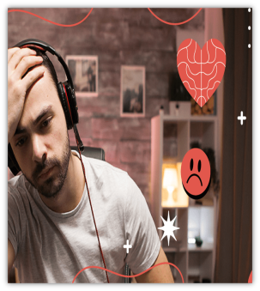

- Security dangers:
- Multiplayer games can put your security at risk. If you share too much personal information, strangers may be able to access your name, email, phone number, and address. Large gaming communities are filled with cyber bullies.
- Hackers can cause your information to be leaked, and viruses are easily spread.
- Responsible gaming
You can limit the dangers by:
- Only playing games and chatting with people you know and trust.
- Not using personal information in your username and passwords or a webcam.
- Accept limits that your parents set to prevent unhealthy gaming habits.
- Make sure that gaming does not replace real-life activities.
- When you do encounter dangers, don’t be afraid to tell your parents. That could include family discussions and increased supervision when using the internet.

Questions

Q1: Put ( ) or ( ):

- There are no good sides to playing electronic games. ( )
- Electronic games don’t encourage teamwork. ( )
- Electronic games may cause back problems. ( )
- If you share too much personal information, strangers may be able to access your name, email, phone number, and address. ( )
- Multiplayer games can put your security at risk. ( )
- It is OK to use personal information in your username and passwords. ( )
- Don’t accept limits that your parents set to prevent unhealthy gaming habits.( )
- Make sure that gaming does not replace real-life activities. ( )

Q2: Choose the correct answer:
- One of the electronic games' physical dangers is …………………………
a. headache b. becoming anxious c. viruses

- Affecting your sleep cycle is one of the dangers of the electronic …………………
a. commerce b. mail c. gaming
- Electronic gaming may let you become …………... because you feel lonely in the real world.
a. depressed b. happy c. aggressive
- Only play games and chat with……………………..
a. strangers b. people you know and trust c. hackers
- When you do encounter dangers, don’t be afraid to tell your …………………..
a. neighbors b. friends c. parents

Lesson2
Protecting Yourself from Digital Theft
It is irresponsible to leave your devices at risk by not taking proper safety precautions.
To protect your devices from theft, use:
1. PASSWORDS
Passwords with at least eight random letters, numbers, and symbols are the most secure.
2. MULTI-FACTOR AUTHENTICATION (MFA)
MFA requires at least two ways of identifying yourself, usually through passwords, pins, and security codes or personal questions.
3. FINGERPRINT AUTHENTICATION
This type of authentication will scan your finger, as a way of confirming your identity
4. FACIAL RECOGNITION
Facial recognition software will scan your face using your device’s camera.
Only the user’s face can be used to open their devices or devices’ apps.
5. FULL ENCRYPTION
Encryption protects your information so only you can access it on your device, as long as you have set your password.
Companies need to protect their websites and their customers’ information. Therefore, Egypt has introduced the Data Protection Law to protect its citizens.
- It requires companies to use strict security standards to protect their data. They must report immediately if they’ve been victims of data theft, and let their customers know immediately as well.
- You should report data theft, too. If you think your data has been compromised, be sure to tell a parent or trusted adult.
- They can let the proper authorities know.
- You should also tell family and friends you communicate with online.
Questions
Q1: Put ( ) or ( ):
- It is irresponsible to leave your devices at risk by not taking proper safety precautions. ( )
- MFA requires at least two ways of identifying yourself. ( )
- Fingerprint authentication will scan your face. ( )
- Encryption protects your information so only you can access it on your device. ( )
- Companies don’t need to protect their websites or their customers’ information. ( )
- You should report data theft. ( )
Q2: Choose the correct answer:
- MFA stands for……………………..
a. Multi-Files Authentication
b. Multi-Factor Authentication
c. Many-Factor Authentication

- MFA could be through………………….
a. passwords and pins
b. security codes or personal question
c. all the previous

- Facial recognition software will scan your face using your device’s ………….
a. camera b. microphone c. screen
- Passwords with at least …….. random letters, numbers, and symbols are the most secure.
a. 5 b. 8 c. 3

Lesson3
Cyber Security
It is irresponsible to leave your devices at risk by not taking proper safety precautions.
Online safety precautions and strategies
- Use safe web browsers and install antivirus protection on your devices.
- Only allow friends and family to view your social media.
- Do not communicate with people you don’t know or who make you feel uncomfortable.
- Do not share personal information online.
- Use strong passwords and change them every three months.
- Verify websites are real, safe, and age-appropriate.
- Verify information you find to make sure it is accurate.
Cyber Security
Cyber Security means the protection of systems, networks, devices, and data from electronic attacks when using information and communication technology applications.
Types of Cyber Security Threats
- Malware:
- This is the greatest cyber security threat. No matter how cautious you are, you may still get tricked.
- Shareware is a type of malware that pretends to be a virus alert. It tells you to click on the link to help remove it, but the link is actually the virus!
- Unsecured Wi-Fi can open you up to malware threats.

- Spoofing:
- Cyber criminals pretend to be a business or a known person in order to trick you into providing your information or clicking on unsafe links. If you click on unsafe links, you are at risk of having your information compromised, money stolen, or viruses installed on your devices.
- Examples of spoofing are:
- A fake domain pretending to be a business.
An email account that has the name of a trusted service or a person you know.
How to deal with cyber security threats
- Let your contacts know right away so they avoid opening anything suspicious.
- Use antivirus software to do a sweep of your computer and remove any viruses.
- Confirm your security settings are up-to-date.
- Change all your passwords, even if you think you have only been hacked on one particular account.
- Report the threat to a trusted adult.
They can decide if further action is necessary, such as reporting it to an internet service provider or getting the authorities involved.

Questions
Q1: Put ( ) or ( ):
- You should use safe web browsers and install antivirus protection on your devices. ( )
- Do not communicate with people you don’t know. ( )
- Share personal information online. ( )
- Verify websites are real and safe. ( )
- Malware is the greatest cyber security threat. ( )
- Secured Wi-Fi can subject you to malware threats. ( )
- You should confirm your security settings are up-to-date. ( )
- Use antivirus software to do a sweep of your computer and remove any viruses. ( )
- If you click on unsafe links, you are in danger of having your money stolen. ( )
- Adults could report cyber security threats to the internet service provider. ( )

Q2: Choose the correct answer:
- Choose …………… passwords for your accounts.
a. strong b. weak c. simple
- Change your passwords every three………………….
a. days b. months c. years
- Verify information you find to make sure it is ………………..
a. wrong b. accurate c. old
- ………means the protection of systems, networks, devices and data from electronic attacks.
a. Cyber security b. Building's security c. Antivirus
- ……………is a type of malware that pretends to be a virus alert.
a. E-mail b. Hacking c. Shareware
- ………..…could be an email account that has the name of a trusted service.
a. Virus b. Antivirus c. Spoofing
- ………….. the threat to a trusted adult.
a. Copy b. Report c. Send

Lesson4
Copyright and Electronic Financial Trading
- Copyright
Copyright (intellectual property rights) means someone’s invention, creation, or idea is protected by law from being copied by someone else, such as an individual or a business.
Copyright includes written, visual, audio, video, and web material.
“Creative Commons" refers to work that has been granted permission to share by the creator.
Work in data libraries such as the Egyptian Knowledge Bank (EKB) is already approved for use.
Egypt states that no creator permission is needed in the public domain if the creator has been deceased for at least 50 years.
- Electronic Financial Trading
- A stock exchange is a market where buyers and sellers deal in units of company stock. These stocks are called shares.
- The Egyptian stock exchange allows citizens to invest in any market sector.
- In traditional settings, an investor will require the assistance of a broker – this is a person who handles the buying and selling of shares. However, electronic financial trading (e-trading) has made the process of buying and selling shares more efficient and provides the investor with more authority.
- With the spread of the internet, electronic trading platforms are now commonplace.
- E-trading allows the investor to make trades on their own through websites or applications.

- While investors can still use a broker, e-trading allows more independence and user-friendly options.
- These include robo-advisors – online Applications that provide financial guidance and services.
- E-trading provides access to many more people who otherwise might not be able to invest.
- It is also easier for different companies to trade with one another faster, no matter where they are located.

Questions
Q1: Put ( ) or ( ):
- Copyright means someone’s invention, creation, or idea that is protected by law from being copied by someone else. ( )
- Copyright includes video and web material only. ( )
- Work in data libraries, such as (EKB) is approved for use. ( )
- A stock exchange is a market where buyers and sellers deal in units of company stock. ( )
- The Egyptian stock exchange allows citizens to invest in a few market sectors.
( )

Q2: Choose the correct answer:
- “………………." refers to work that has been granted permission to share by the creator.
a. Creative Commons b. Copyright c. Facts
- Egypt states that no creator permission is needed in the public domain if the creator has been deceased for at least ……. years.
a. 10 b. 50 c. 100
- With the spread of the internet, ………………. platforms are now commonplace.
a. shops b. games c. e-trading

Lesson 5
Cloud Storage of Files
- What is cloud computing?
It is the on-demand storing and accessing of data and programs via remote servers on the internet.
It enables users to access files and data easily from anywhere and at any time.
Remote servers connect users who are not on the local area network (LAN) to access and manage data, files, and applications via the internet.
Examples:
Microsoft 365, with its application OneDrive
Google, with its application Google Drive
- The advantages of cloud computing:
- It frees up space on your devices by using cloud storage services.
- It allows you to log in and access your files from multiple devices, as long as you have internet service.
- It provides a backup for your files.
- It provides an extra layer of security by offering password-protected data storage and data encryption.
- It allows you to directly share files with authorized users.
- The disadvantages of cloud computing:
- It requires you to have an internet connection. If you lose your internet connection, you won’t be able to access files that are only stored in the cloud.
- Cloud storage is often a fee-based service. If you want to store files, you will need to pay a fee – the more storage you require, the higher the fee you will pay.

- If the cloud service you are using is a victim of a data breach, you may become a victim as well, as your information may be compromised. However, while there is a small risk, cloud services are overall extremely safe and secure.
A data breach occurs when unauthorized parties gain access to confidential data and information.
- Storing files in the cloud
Having a document management system allows you to organize your documents so that it is quick and easy to find them.
1- Create separate folders for different types of data, like photos, videos, audio
files, and documents.
2- Separate school and personal information with one folder for each.
3- Label folders and subfolders clearly, so it’s easy to find what you are looking
for.
4- Create strong passwords for files and have security measures in place.
5- Be sure to use a strong password for any account you have on a cloud storage
platform, including Multi Factor Authentication (MFA) for additional security.
- All the large and reputable cloud storage services offer MFA.

Questions

Q1: Put ( ) or ( ):
- Cloud computing enables users to access files easily from anywhere and at any time. ( )
- Remote servers connect users who are on the local area network (LAN) to access data via the internet. ( )
- One of the advantages of cloud computing is that it frees up space on your devices. ( )
- Cloud computing allows you to log in and access your files from one device only. ( )
- Cloud computing doesn’t require you to have an internet connection. ( )
- Cloud storage is often a free service. ( )
- If the cloud service you are using is a victim of a data breach, you may become a victim too. ( )
- Having a document management system allows you to organize your documents. ( )
- Separate school and personal information with one folder for each. ( )
- All the large and reputable cloud storage services don’t offer MFA. ( )
- Keep separate folders depending on the file type. ( )
- Be sure to use a strong password for any account you have on a cloud storage platform. ( )

Q2: Choose the correct answer:
- The cloud computing used in Microsoft 365 is …………….application.
a. OneNote b. OneDrive c. Google Drive
- Cloud computing provides……………….
a. a backup for your files b. an extra layer of security c. (a & b)
- Data encryption converts data into a code to prevent ………………….user access.
a. all b. unauthorized c. authorized
- A ......…..occurs when unauthorized parties gain access to confidential data and information.
a. data breach b. data encryption c. database
- Label ……… and subfolders clearly, so it’s easy to find what you are looking for.
a. programs b. folders c. applications
- Create ……………… passwords for files.
a. easy b. weak c. strong

Lesson 6
Cloud Computing Applications
Microsoft 365 and Google Workspace are the most popular software that deal with cloud computing applications.
Microsoft 365 offers a whole suite of productivity apps such as Teams, Word, Excel, and PowerPoint, its e-mail platform, Outlook, and the Microsoft 365 storage application OneDrive.
- Microsoft Word lets you open a blank document that allows you to draft ideas, a story, or an assignment.
- PowerPoint helps you create a presentation.
- OneDrive helps you share work with your friends.
OneDrive
OneDrive allows you to store, share, and access files from any device. It’s very user-friendly.
You upload your files and then click on the share option to share with others.
You can decide what level of access each person you share with gets, whether it’s for viewing purposes only or editing.
How to upload files or folders to OneDrive:
- In Chrome, sign in to the Microsoft Office.
- Select OneDrive.
- Select “Upload Files” or “Upload Folder”.
- Select the files or folder you want to upload.
- Select “Open” or select “Folder”.

How to save a file to OneDrive
- Select File > Save a Copy > OneDrive – Personal/Company.
- Select “Enter file name here” and type a name.
- Select “Save”.
You will then see the file in your OneDrive the next time you open the Office app.

Questions
Q1: Put ( ) or ( ):
- Google offers a whole suite of productivity apps such as Teams and Word. ( )
- Microsoft 365 and Google Workspace are the most popular software that deal with cloud computing applications. ( )
- The Paint program allows you to store, share, and access files from any device. ( )
- You can’t decide what level of access each person you share with will get. ( )
- We can upload files to OneDrive only. ( )
Q2: Choose the correct answer:
- Microsoft e-mail platform is …………………..
a. Outlook b. Gmail c. Yahoo mail
- Microsoft ………………..lets you open a blank document that allows you to draft ideas, a story, or an assignment.
a. Excel b. Teams c. Word
- PowerPoint helps you create a ……………………….
a. mail b. presentation c. folder
- ……………..helps you share work with your friends.
a. Website b. OneDrive c. PowerPoint
- In OneDrive, upload your files and then click on the …………..option to share with others.
a. share b. save c. open

